**Assignment 1**: Draw your Home Network Topology and explain how you are accessing the RPS Lab environment.

**Router:** The router is the central hub of the home network. It manages the data traffic between devices within the network and also serve as a gateway between the home network and the network.

**Switches:** Switches are used to connect multiple devices within a local network. In above network system, there are three devices are connected to switch.

**RPS Lab:** The RPS lab is present outside of the home network and we can access it through using VPN easily. A VPN creates a secure, encrypted connection over the internet, allowing you to access resources on the lab’s networks as if you were physically present there. Once connected the VPN, you can use remote desktop software to access specific server within the lab environment.

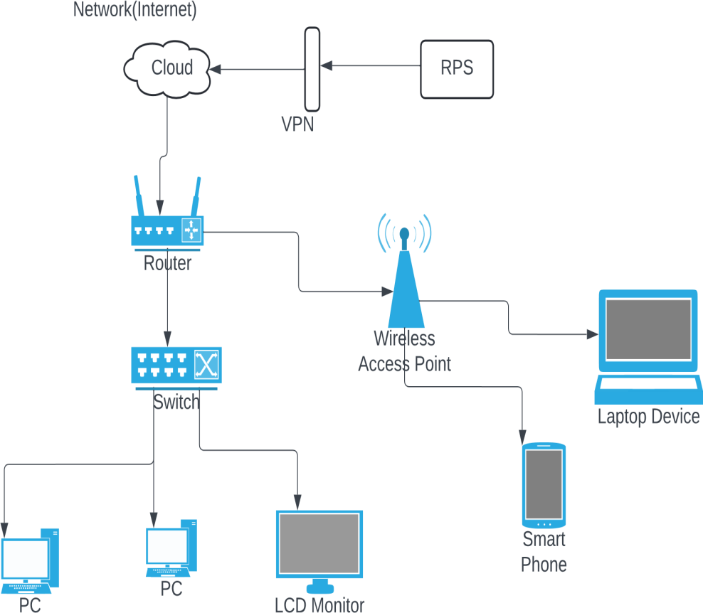

**HOME NETWORK TOPOLOGY**

**Assignment 2:** Identify a real-world application for both parallel computing and networked systems. Explain how these technologies are used and why they are important in that context.

**Parallel computing**:

Parallel computing is a type of computation in which many calculations or processes are carried out simultaneously. Large problems can often be divided into smaller ones, which can then be solved at the same time.

**Real-World Example:**

**Weather Forecasting:**

* Weather forecasting involves processing vast amount of data from various sources, including satellite images, weather stations, and atmospheric models. These data sources provide information about temperature, humidity, wind speed, atmospheric pressure, and other atmospheric variables at different locations and altitude.
* Meteorologists use numerical models to simulate the behavior of the atmosphere and predict how weather patterns will evolve overtime.
* Parallel computing allows meteorologists to divide the computational workload of running these numerical models among multiple processors or computing nodes. Instead of running entire simulation on a single processor, parallel computing enables the simulation to be split into smaller tasks that can be executed simultaneously by different processors.